**Assignment – 1**

* **Install Power BI Desktop and share the final screenshot of the report view page which appears when power desktop starts.**

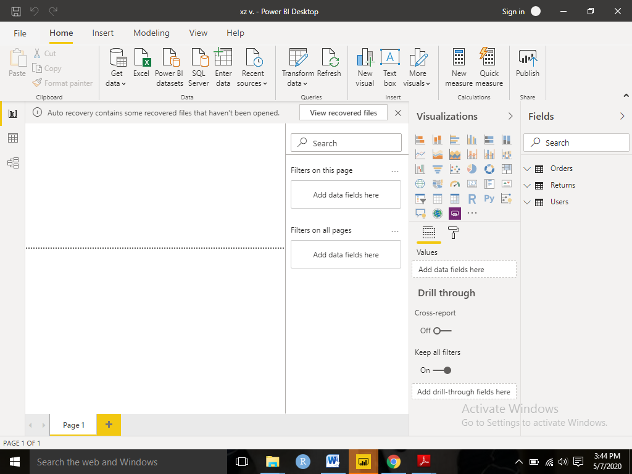

* **Prepare a document and with the following screenshot**

− Report View

− Data View

− Model View

− Power Query Editor

− Advance Editor

* Report View

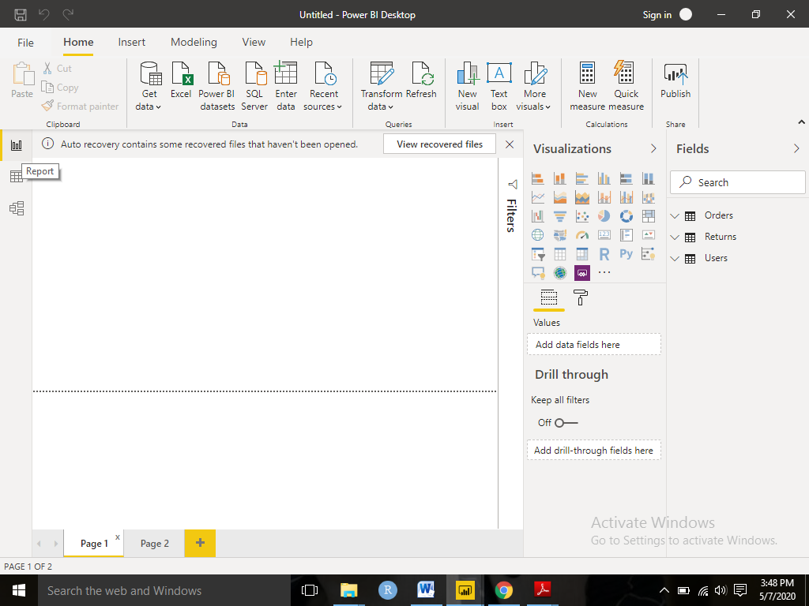

* Data View

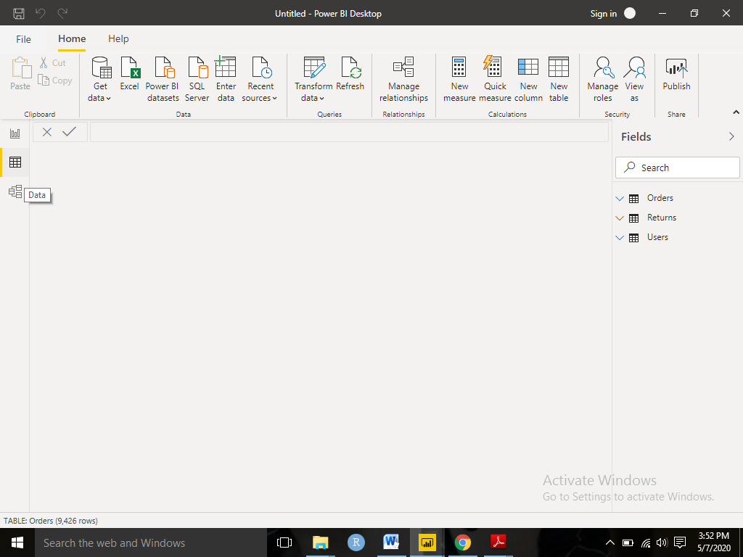

* Model View

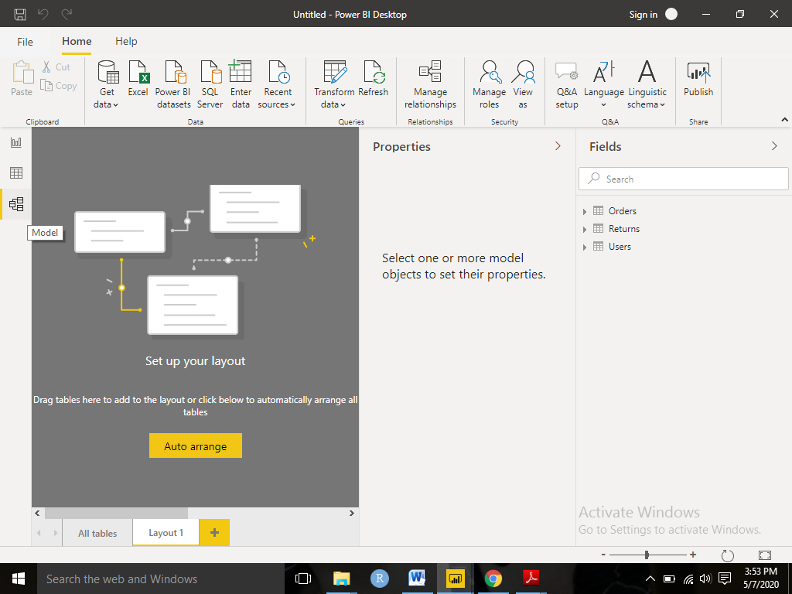

* Power Query Editor

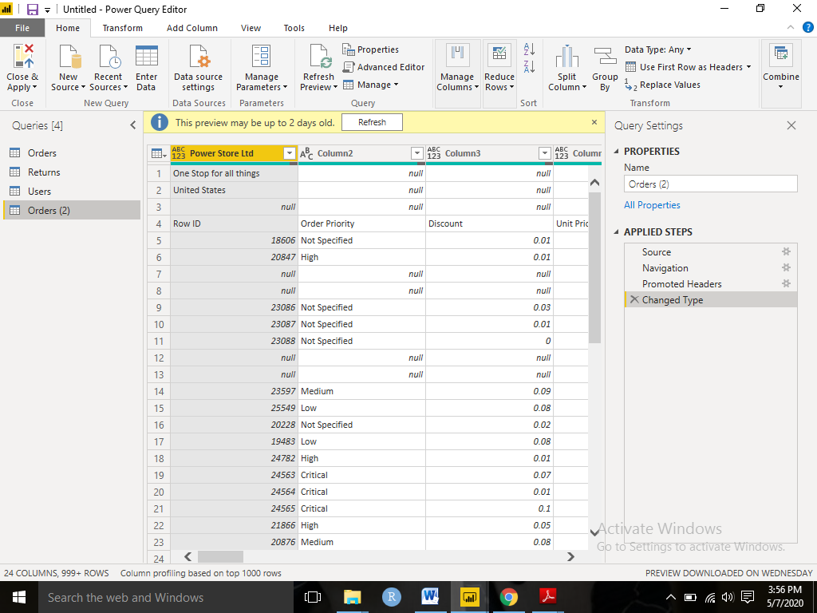

* Advance Editor

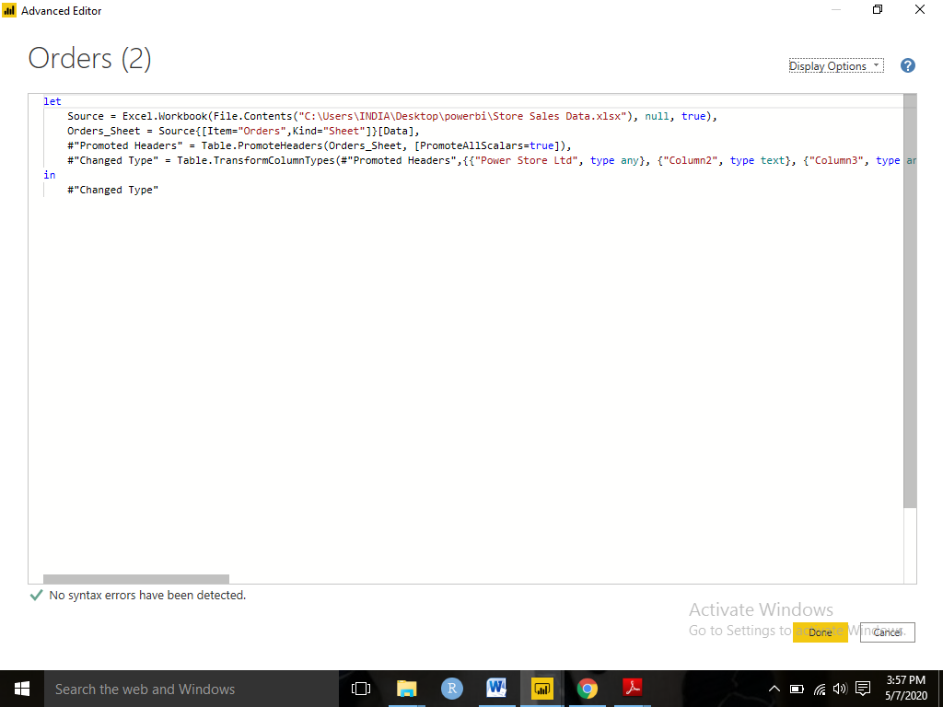

* **Prepare a document with details of the following along with their price**

− Power BI Desktop

− Power BI Pro

− Power BI Premium

* Power BI Desktop

Power BI Desktop is a “free of charge” to install in our desktops it let us to connect the data, then transform, and visualize. With Power BI Desktop, we can connect to multiple data sources, and combine them into a data model. This data model gives us the insights of data to build visuals, and collections of visuals we can share as reports, with our organization. Most users who work on business intelligence projects use Power BI Desktop to create reports, and then use the Power BI service to share their reports with others.

The most common uses for Power BI Desktop are as follows:

* Connect to data
* Transform and clean the connected data, to create a data model
* Create visuals, such as charts or graphs, that provide visual representations of the data
* Create reports that are collections of visuals
* Share reports with others by using the Power BI service

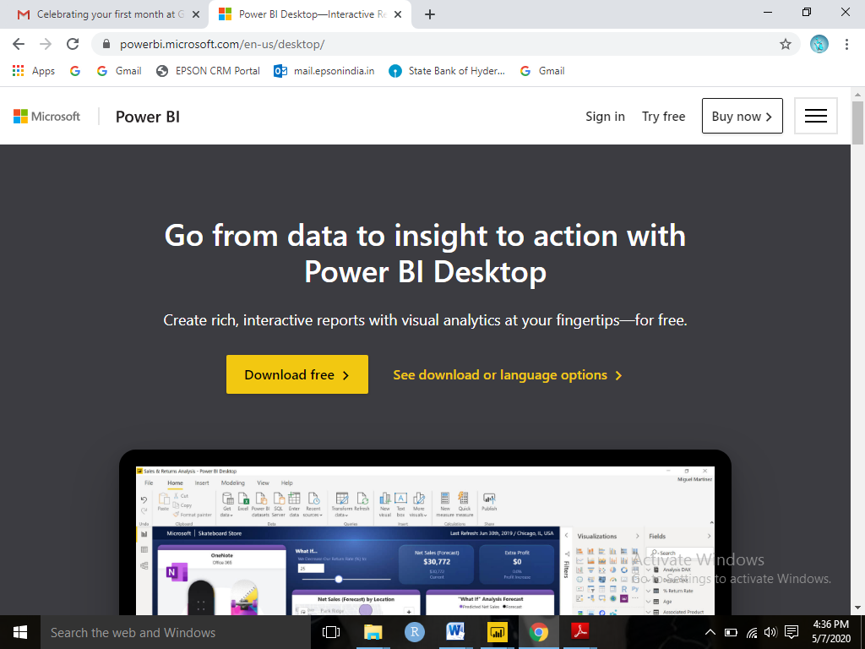

* Power BI Pro
* A business analytics service to
* Get a self-serve analytics platform that scales across the organization.
* Find and share meaningful insights using smart tools.
* Help keep your data secure and compliant—even when exported.
* Reduce the added cost and complexity of multiple solutions.

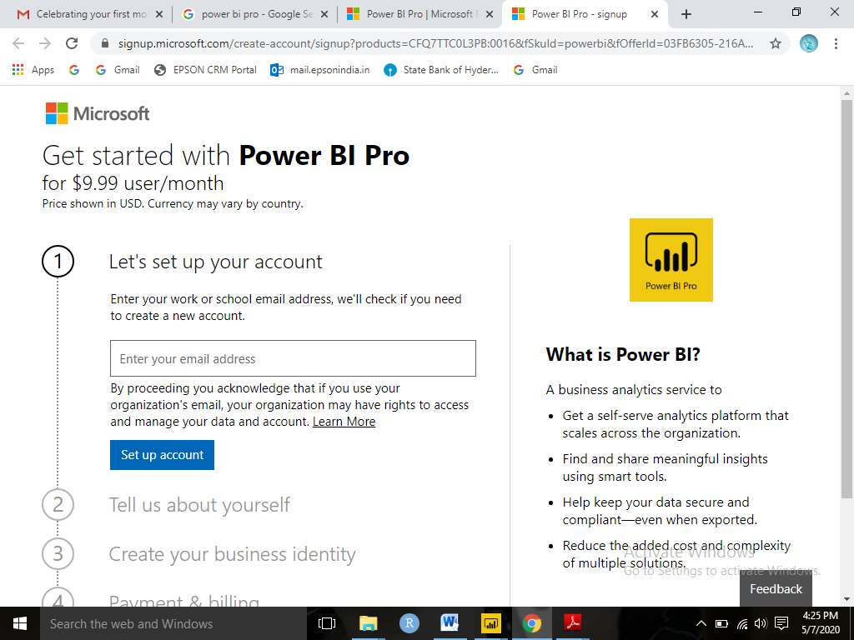

* Power BI Premium

We can use Power BI Premium to get dedicated and enhanced resources for our organization, so users in our organization can use the Power BI service with better performance and responsiveness. For example, with a Power BI Premium subscription, organization's users get access to the following:

* Greater scale and performance
* Flexibility to license by capacity
* Unify self-service and enterprise BI
* Extend on-premises BI with Power BI Report Server
* Support for data residency by region (Multi-Geo)
* Share data with anyone without purchasing a per-user license

